IT 230 — Final Project Part II
WPF Register Student
Norman Whitney

Program Testing and Screenshots
Screenshot 1 — Successful registration
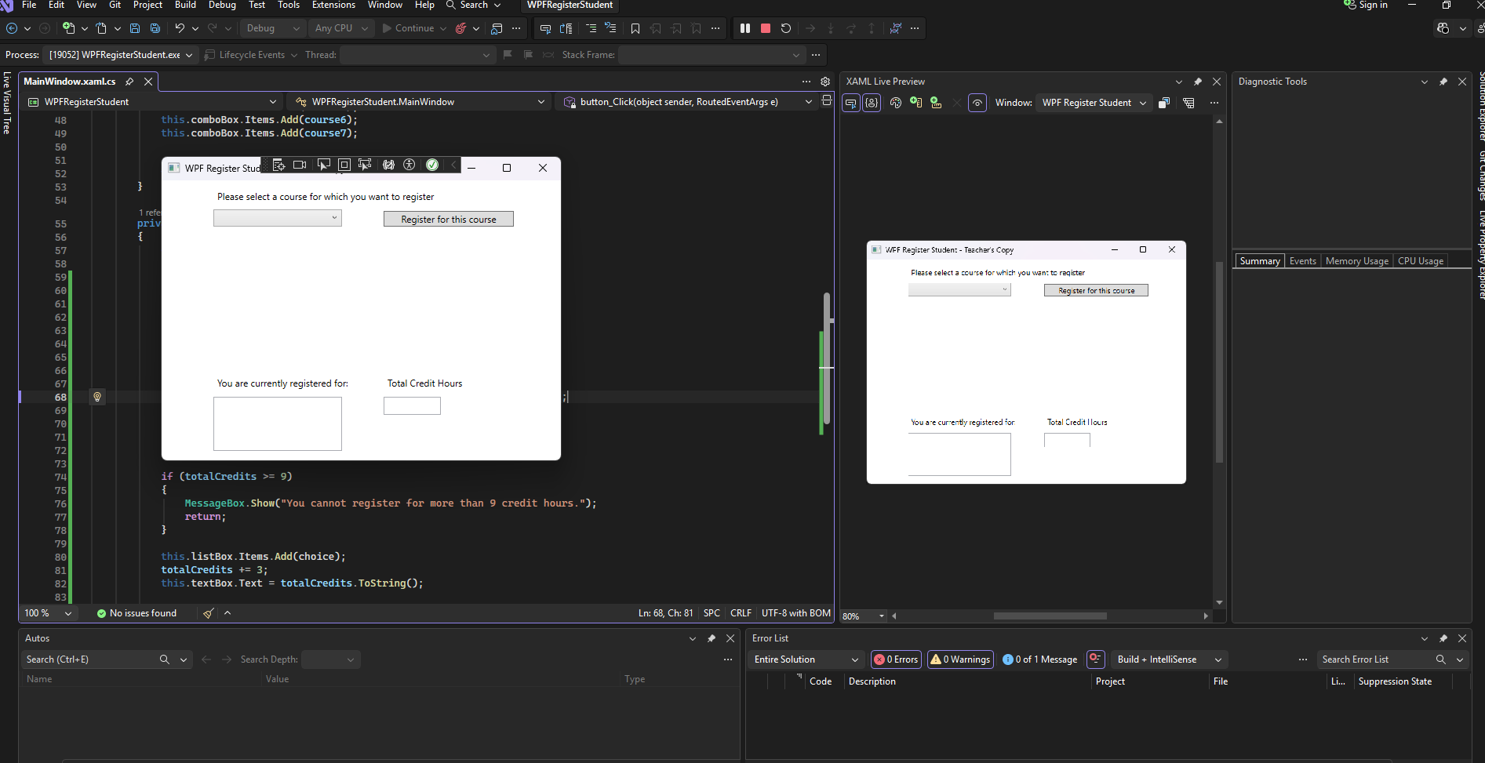
The application registers IT 145 and displays 3 total credit hours.

Screenshot 2 — Duplicate registration prevented
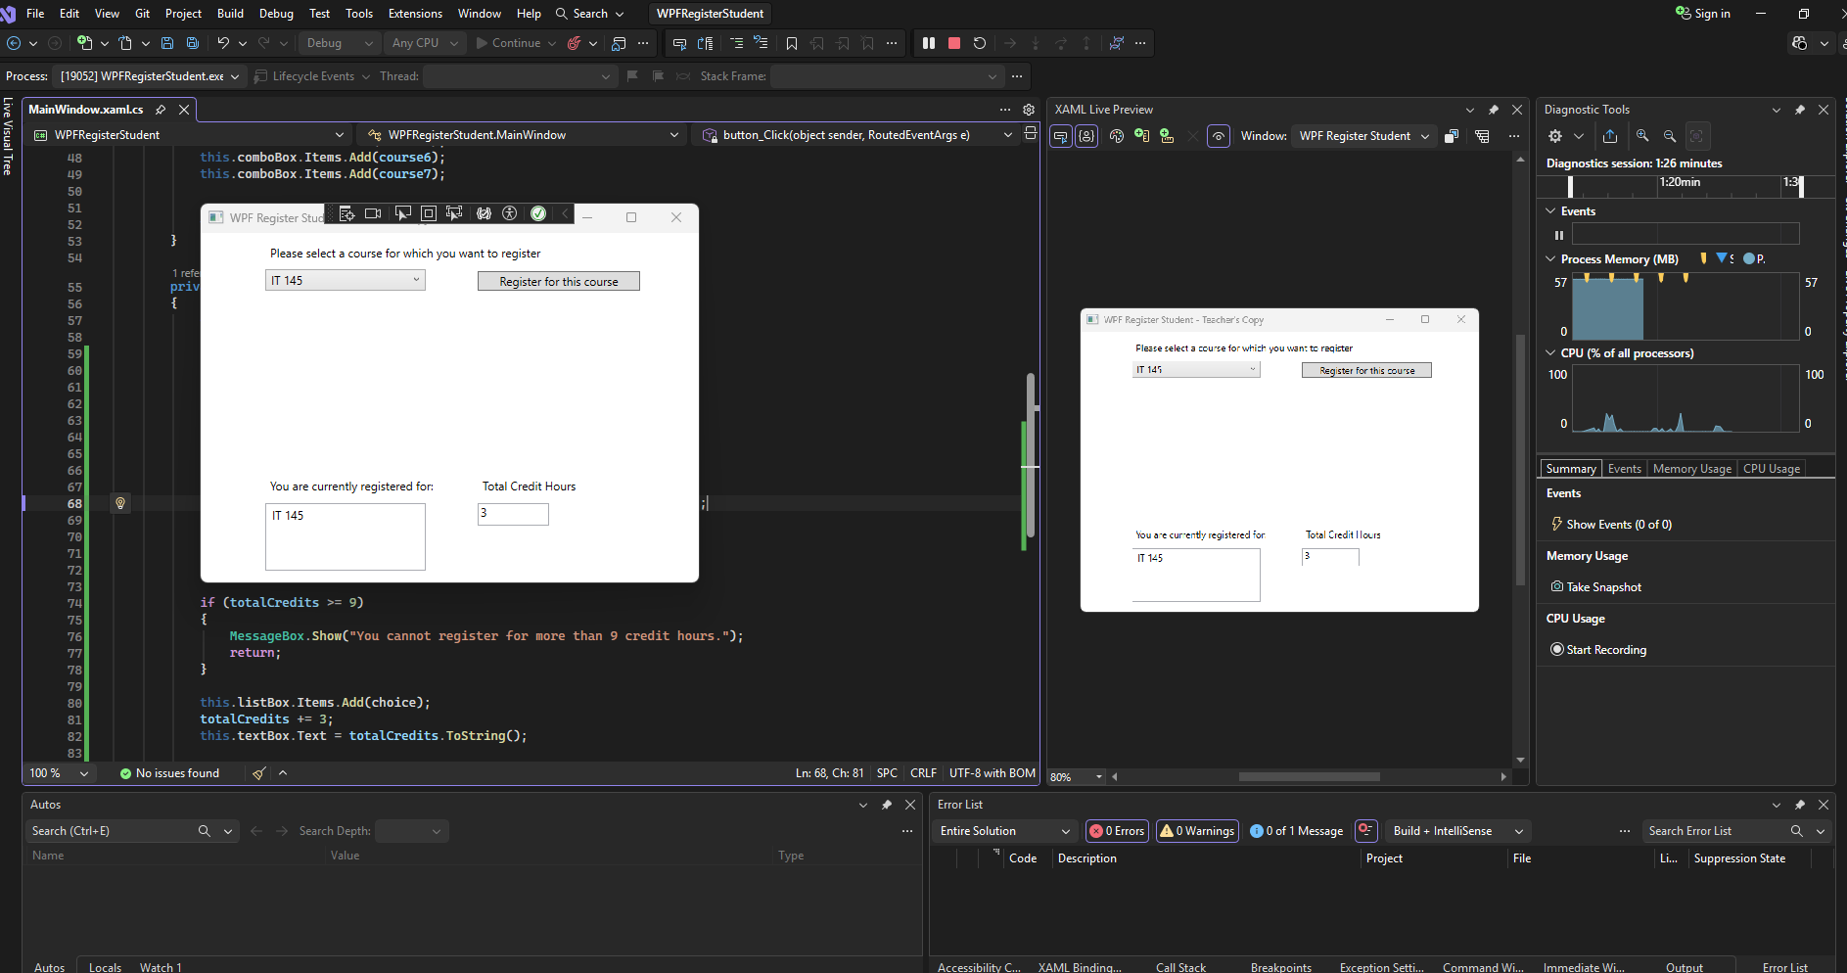
Attempting to register IT 145 again displays an error. The list still contains only IT 145 and the total remains 3.

Screenshot 3 — Three courses and nine credits
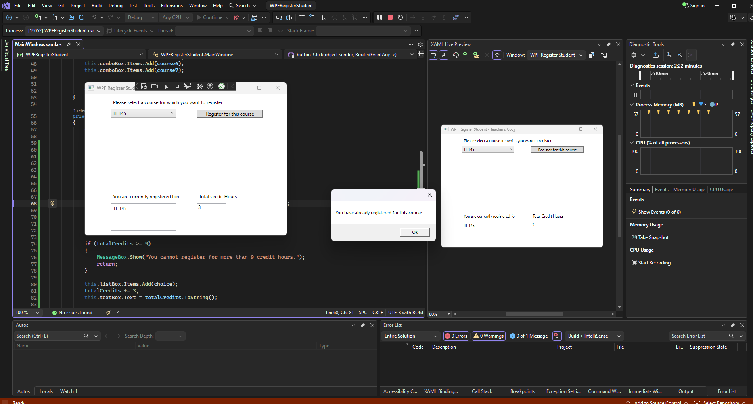
The application registers IT 145, IT 200, and IT 201. Each course is worth three credits, for a total of 9.

Screenshot 4 — Fourth course rejected
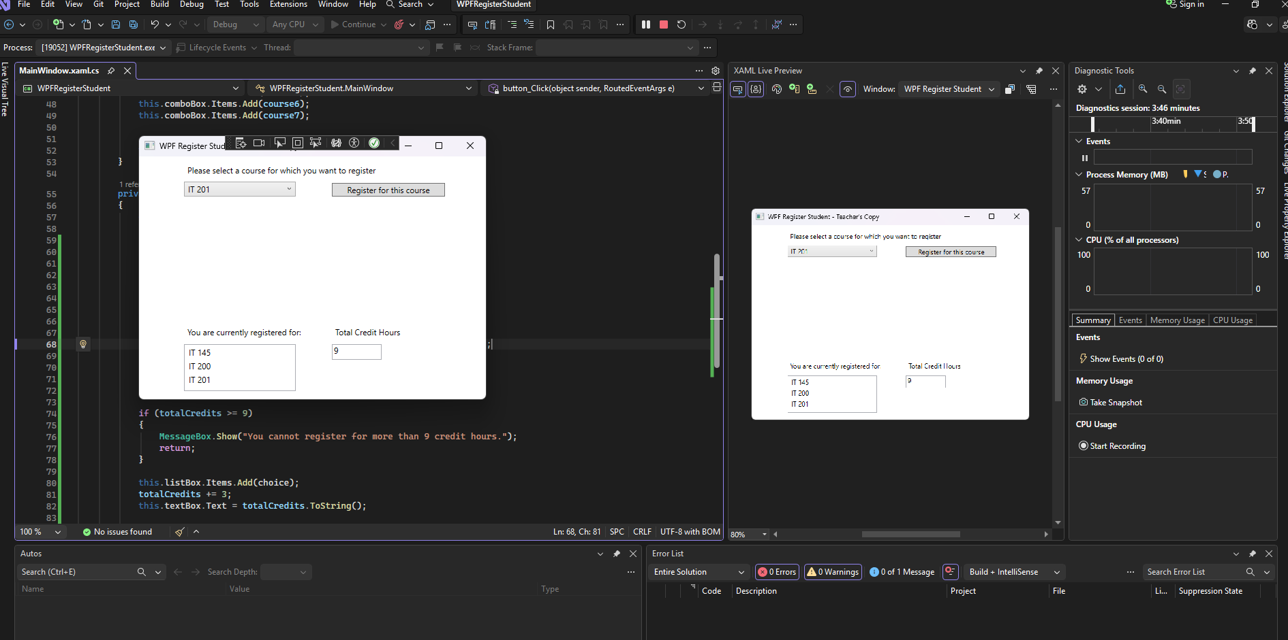
Attempting to add IT 270 displays the nine-credit-limit warning. The existing three courses and total of 9 credits remain unchanged.

Source Code — MainWindow.xaml.cs
The following is the starter MainWindow.xaml.cs source with the registration logic added to button_Click().
using System;
using System.Collections.Generic;
using System.Linq;
using System.Text;
using System.Threading.Tasks;
using System.Windows;
using System.Windows.Controls;
using System.Windows.Data;
using System.Windows.Documents;
using System.Windows.Input;
using System.Windows.Media;
using System.Windows.Media.Imaging;
using System.Windows.Navigation;
using System.Windows.Shapes;

namespace WPFRegisterStudent
{
/// <summary>
/// Interaction logic for MainWindow.xaml
/// </summary>
public partial class MainWindow : Window
{
Course choice;

public MainWindow()
{
InitializeComponent();
}

private void Window_Loaded(object sender, RoutedEventArgs e)
{

Course course1 = new Course("IT 145");
Course course2 = new Course("IT 200");
Course course3 = new Course("IT 201");
Course course4 = new Course("IT 270");
Course course5 = new Course("IT 315");
Course course6 = new Course("IT 328");
Course course7 = new Course("IT 330");

this.comboBox.Items.Add(course1);
this.comboBox.Items.Add(course2);
this.comboBox.Items.Add(course3);
this.comboBox.Items.Add(course4);
this.comboBox.Items.Add(course5);
this.comboBox.Items.Add(course6);
this.comboBox.Items.Add(course7);

this.textBox.Text = "";
}

private void button_Click(object sender, RoutedEventArgs e)
{
choice = (Course)(this.comboBox.SelectedItem);

if (choice == null)
{
MessageBox.Show("Please select a course.");
return;
}

if (this.listBox.Items.Contains(choice))
{
MessageBox.Show("You have already registered for this course.");
return;
}

int totalCredits = this.listBox.Items.Count * 3;

if (totalCredits >= 9)
{
MessageBox.Show("You cannot register for more than 9 credit hours.");
return;
}

this.listBox.Items.Add(choice);
totalCredits += 3;
this.textBox.Text = totalCredits.ToString();

MessageBox.Show("Successfully registered for " + choice.ToString()); }

}
}

